OCEANA COUNTY 4-H MARKET LIVESTOCK
EDUCATIONAL NOTEBOOK/RECORD



LITTLE BUDDY HOG PROJECT- 2025

AGES 5 – 7 YEARS

As a member of the 4-H Market Livestock Little Buddy Hog Project, you are required to submit your records as part of an educational notebook project in order to show your animal at the Oceana County Fair. This notebook must be shown to the Oceana County 4-H Market Livestock Committee’s Weighmaster at the time of weigh-in and then entered by you in the Educational Notebook Division of the Oceana County Fair on Entry day.

AGE _____

Remember: The age you enter depends on how old you are on or will be on January 1, 2025.

NUMBER OF YEARS IN PROJECT ________

Use this sheet as the first page of your project record book. Fill it out completely.
Please print or type neatly.

NAME _________________________________________________________________

4-H CLUB _______________________________________________________________

BREED _________________________________________________________________

SWINE’S NAME __________________________________________________________

NAME OF BIG BUDDY ____________________________________________________

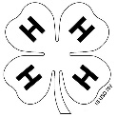

JUDGE’S SCORE/COMMENT SHEET

(PLEASE DO NOT REMOVE, PLACE THIS SHEET IN SHEET PROTECTOR OR GLUE TO COVER). This sheet must be kept free for the judge to write their comments.

This sheet should help each 4-H’er understand their ribbon placing.

A. Specific educational value or worth

___ All questions were answered completely

___ All calculations were correct

___ Calculations were incorrect

___ Questions were not answered (missed questions)

B. Notebook contains all project records

___ Notebook contained all project records and were fully completed

___ Notebook contained additional project related information (research

materials etc.)

___ Project records were incomplete

___There was no additional project related information

C. Accuracy, neatness and general appearance

___Notebook was neat in appearance (typed/hand printed)

___Notebook pages were clean and stain free

___Notebook pages were in order and complete

___Notebook was difficult to read and messy

__Notebook had wrinkled and stained pages

Other Comments: ______________________________________________________

__________________________________________________________________

__________________________________________________________________

LITTLE BUDDY HOG NOTEBOOK

TABLE OF CONTENTS

Please keep your notebook in Table of Contents order.

- GENERAL GUIDELINE INFORMATION

- ABOUT YOUR PIG

- JOURNAL OF CARE

- PROJECT INFORMATION & PARTS OF A PIG

- YOUR PROJECT
  - My 4-H Project
  - 4-H Knowledge

- PICTURES OF YOUR PROJECT (1 page)

APPENDIXES (OPTIONAL):

- PICTURES OF YOUR PROJECT (additional pictures)

- FEED INFORMATION (example: feed labels etc.)

- ADDITIONAL INFORMATION ABOUT YOUR PROJECT
* Include notes as to why you researched this information and found it
Valuable, link it to your project if possible.

  - Information you found in reference materials
  - Worksheets you did with your club
  - Information you located off the internet
  - Information from your feed store representative
  - Any other information

2025- Little Buddy Hog Record Book (5-7) Page 1

This record book is part of your 4-H Market Hog Project. By keeping records up-to-date you will be able to see how much progress you make as you set goals and work to accomplish them. Write neatly and clearly. Feel free to add extra pages.

FAIR ENTRY RULES

If you are between the ages of 5 and 7 years old and elect to participate with your 4-H number at the Oceana County Fair you will be awarded a participation ribbon for your efforts.

In order to compete for an “A”, “B” or “C” you will have to enter you record book in the “Open Educational Notebook Class” with a Y “youth” number provided by the Oceana Agricultural Society.

If you have questions, please contact your leader or the MSU Extension Office as fair approaches.

PROJECT PICTURES

Pictures are a required part of this notebook. Taking pictures of your project animal throughout the project will indicate how your animal has grown and developed. Add pictures to your notebook on a separate piece of paper.

SCORING CRITERIA

The following breakdown will be used during the judging process of all market livestock notebooks.

A. Specific educational value or worth 30%

B. Creative way of showing what has been learned 10%

C. Notebook contains all project records 50%

D. Accuracy, neatness and general appearance 10%

The Oceana County 4-H Market Livestock Committee encourages 4-H leader and parent assistance with your project and project notebook. If you should have any questions, please contact the MSU Extension Office.

I, ____________________________ assisted ________________________ in
Parent/Leader/Adult Name 4-Her’s Name
understanding the questions and writing the answers. All answers are those of the 4-Her.

____________________________________
Signature of person helping with notebook
If written help was needed
2025- Little Buddy Hog Record Book (5-7) Page 2

ABOUT YOUR BIG BUDDY’S PIG

The Pig’s Name is: _____________________________________________

The Pig’s breed is: _____________________________________________

What color is the Pig? _________________________________________

The Pig’s favorite things to do is: __________________________________

_____________________________________________________________

My Pigs is a (circle one): Barrow (boy pig) Gilt (girl pig)

COLOR THIS PIG TO LOOK LIKE YOURS
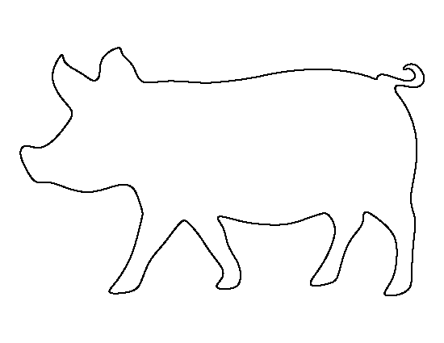

2025- Little Buddy Hog Record Book (5-7) Page 3

ANIMAL CARE AND MANAGEMENT- JOURNAL OF CARE

Your project requires regular care and management. It is assumed that you helped walk & feed your animal but what additional things have you done?

Include the following:
- Feeding and watering practices
- Grooming (clipping, toenail trimming, washing, etc.)
- Health practices and medicines (vaccinations, etc.)
- General Management (cleaning living area, feed pans, etc.)

Daily- Things done once or twice a day
Weekly- Things done once or twice a week
Monthly- Things done once a month
Yearly- Things done one time or occasionally throughout the year

My little buddy helped me with the care and training of our project animal.

Signature of Big Buddy: _________________________________ Date: ____________
2025- Little Buddy Hog Record Book (5-7) Page 4

PROJECT INFORMATION

The start of the project will be the date the 4-Her placed the animal on feed, not any later than June 1st of the current year. The end of the project will be weigh-in day at the Fair.

Project Start Date _ Project End Date _____________Pig Date of Birth_______
Fair Haul In Day

Please complete the following chart about your project. Have your Big Buddy help you.

4-HTag  Number | USDA Tag Number | Breed | Gender of pig | Price or Value | Estimated Starting Weight | Ending/ Final Weight (FW) | Total Pounds Gained
Note: Total pounds gained = ending weight – starting weight

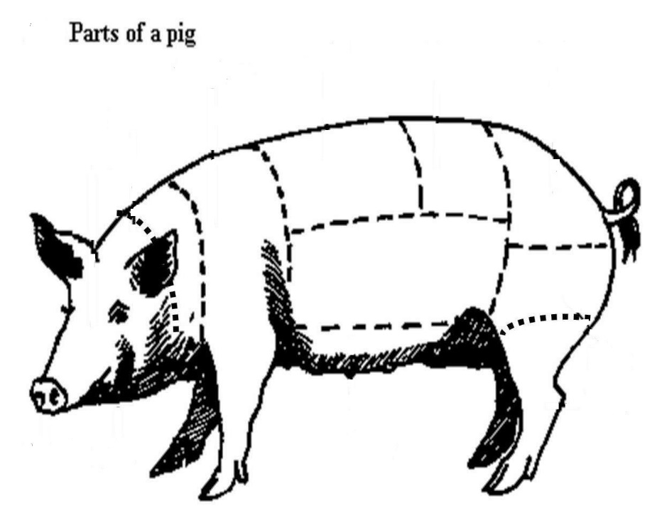

Color the parts of the pig:

BACK- PURPLE HOCK- PURPLE RUMP- GREEN
BELLY-YELLOW LOIN- BLUE SHOULDER- ORANGE
FACE- GREEN NECK-BLACK SNOUT- RED
HAM- PINK RIBS- BROWN TAIL- YELLOW

2025- Little Buddy Hog Record Book (5-7) Page 5

YOUR PROJECT

Please answer the following questions to be the best of your ability.

1. What did you have the most fun doing with your project?

_____________________________________________________________

_____________________________________________________________

_____________________________________________________________

_____________________________________________________________

2. What was the hardest part of your project?

_____________________________________________________________

_____________________________________________________________

_____________________________________________________________

_____________________________________________________________

3. Will you do a swine project again? Why or why not?

_____________________________________________________________

_____________________________________________________________

_____________________________________________________________

_____________________________________________________________

2025- Little Buddy Hog Record Book (5-7) Page 6

4-H KNOWLEDGE

The 4-H Pledge- Draw a line to the picture that fills in the blank (see the example)

I pledge…
HANDS

HEALTH

HEAD

HEART

WORLD

COUNTRY

CLUB

COMMUNITY
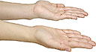









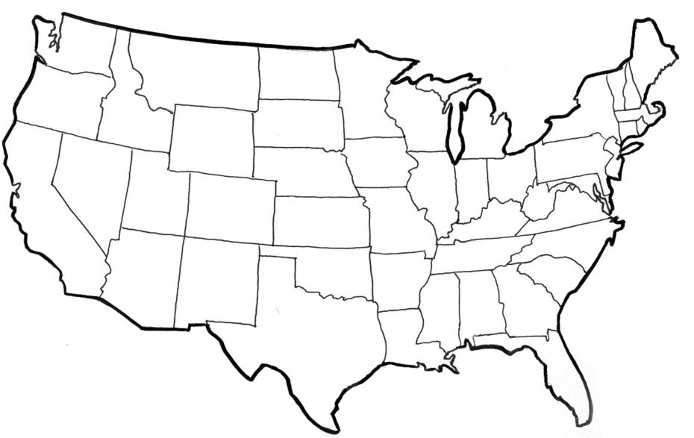

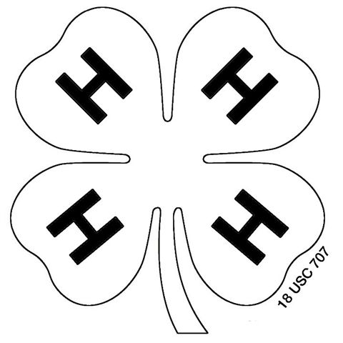



My ____________ to clearer thinking,

My ____________ to greater loyalty,

My ____________ to larger service, and

My _____________ to better living,

for my ____________________,

my _______________________,

my _______________________,

and my ____________________.

2025- Little Buddy Hog Record Book (5-7) Page 7

YOUR PROJECT PICTURES

Please use this page for your project pictures and to tell anything special, that you might want the judge to know, about you and your project animal. The judges like it if you caption your pictures so they know what they are viewing.

CLUB POINTS
MARKET LIVESTOCK ATTENDANCE RECORD- ALL AGES MUST COMPLETE

MEETING NAME | LOCATION | DATE | POINTS | SIGNATURE OF LEADER, SUPERINTENDENT OR MSU STAFF

Please note: This form must be included with your record notebook and turned into the weigh master on entry day of the Fair. You need to accumulate six (6) Club points to be considered as completing your project. Non-club points are not required for Ages 5-7 in this project. If you would like to include those in your book please get a non-club point sheet from MSU Extension and include in the back of your notebook.

